Help stop the spread of Coronavirus
1.5M
Don’t shake hands or make any physical greetings
Stay 1.5 metres apart from other people
Do not enter if you are experiencing flu like symptoms or have recently travelled
Please call (enter phone number) and we will be happy to assist with your enquiries

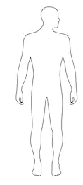
Help stop the spread

